Rotating Spacecraft Lagrangian Neural Networks
  - The attitude and centrifuge models explained in plain language
JunXi Wu
October 12 2026

What this report explains
There are two completed rotating experiments. The attitude model predicts how the hub turns when gravity and a weak magnetic field twist it. The centrifuge model predicts how two spinning arms stretch, how the spin rate changes and how much artificial gravity the habitat experiences. This report derives their equations step by step, connects those equations to the code and explains the measured results.
Both networks learn an energy landscape while the code supplies the known rules for motion. This makes them small, structured Lagrangian neural networks. They learn useful forces; the experiment does not ask them to discover mass, kinetic energy or every conservation rule from scratch.
Model | Main measured result | Test setting
Attitude | Angle RMSE 0.014775 degrees | One planar rotation; fixed stellar distances; about 382 days
Centrifuge | Habitat extension RMSE 0.609778 millimeters | Two elastic arms; one spin angle; 20 seconds

The conclusion supported by these tests
The reduced models give accurate motion in the tested cases, with particularly small physical energy error in the centrifuge. Their learned energy is conserved even more closely. This is promising evidence for learning local potential forces when the kinetic equations are already known.
Each model has one training seed and one reported trajectory. The hub and rotor are treated separately, the attitude calculation freezes the stars, and the centrifuge uses its own local clock. The results therefore do not establish a fully coupled spacecraft model or high-speed relativistic artificial gravity.
The saved checkpoints were evaluated again for this report. Every metric matched the archived result exactly. The analytical equation checks also passed. These are evaluations of the existing trained models; no new training result is claimed.

How energy becomes a rule for motion
Kinetic energy, written T, is energy held in motion. Potential energy, written U, is stored energy that changes when a position or orientation changes. A stretched cable stores potential energy; a turning mass has kinetic energy. The Lagrangian is the difference between them.
$$L(q, q̇) = T(q, q̇) − U(q)$$
Here q means a position or angle, a dot means a rate of change with time, and two dots mean acceleration. With several coordinates, q stands for the whole list. For example, the centrifuge uses two extensions and one spin angle.
The Euler–Lagrange rule says that the change in momentum equals the force obtained from how the energy landscape varies. In a model without an outside drive, the rule is
$$\frac{d}{\text{dt}}(\frac{∂L}{∂{q̇}_{i}}) − \frac{∂L}{∂q_{i}} = 0$$
The symbol ∂ means that we change one input while holding the others fixed. For an ordinary mass, L = ½m q̇² − U. The first derivative gives momentum m q̇, its time derivative gives m q̈, and the last term gives the slope of U. The familiar force law follows directly.
$$m q̈ = −\frac{\text{dU}}{\text{dq}}$$

The calculation used in the code
For several moving parts, expand the time derivative with the chain rule. Let H be the second derivative of L with respect to the rates, and let C describe how momentum changes with position. Then the code solves the following equation for acceleration.
$$H = L_{q̇q̇} ; C = L_{q̇q} ; Hq̈ = L_{q} − Cq̇$$
The function equation_of_motion in phm_lnn.py performs these derivatives with JAX and uses a pseudoinverse to solve the equation. Automatic differentiation applies calculus to the implemented formula; it does not estimate slopes by moving inputs a tiny distance. The code returns the current rates followed by the calculated accelerations.
In these rotating models H comes from the supplied kinetic energy. It is positive for positive masses, inertia and nonzero arm radii. The network changes the potential forces, while this known geometry keeps the acceleration calculation well defined. Both experiments pass generalized_force=None, meaning that no engine thrust or external motor is applied.

Where the gravity gradient formula comes from
The turning effect starts with ordinary Newtonian gravity. Let D be the vector from a star to the hub center, d its length, and a the position of a tiny piece of hub relative to that center. Each piece has gravitational energy −μ dm/|D + a|, where dm is its small mass and μ is the star’s gravitational parameter. Adding all the pieces means integrating.
$$U = −μ ∫ \frac{\text{dm}}{|D + a|}$$
The hub is tiny compared with the star distance. We can therefore expand the inverse distance in powers of its small internal size. Let u = D/d be the unit direction. Keep terms through the square of a; higher powers are neglected in this gravity-gradient approximation.
$$\frac{1}{|D + a|} ≈ \frac{1}{d} − \frac{u · a}{d^{2}} + \frac{3{(u · a)}^{2} − {|a|}^{2}}{2d^{3}}$$
The first term gives −μM/d, the same energy as concentrating the entire mass at its center. The term linear in a vanishes because that center is the center of mass: ∫a dm = 0. The quadratic term is the first term that notices the shape and orientation of the hub.
$$U_{\text{shape}} = −\frac{μ}{2d^{3}}∫ [3{(u · a)}^{2} − {|a|}^{2}] dm$$
Define a matrix S that adds the products of the internal position components, weighted by their masses. Its trace is the integral of |a|²; uᵀSu is the integral of (u · a)². This lets us write the same energy more compactly.
$$S = ∫ a a^{T} dm ; U_{\text{shape}} = −\frac{μ}{2d^{3}}(3u^{T}S u − tr S)$$
The inertia tensor is I = (tr S)1 − S, where 1 is the identity matrix. Its trace is 2 tr S. Substitute this relation: tr I − 3uᵀIu equals 3uᵀSu − tr S. Express the direction in the hub’s body frame as n and add the two stars.
$$U_{\text{gg}} = −\frac{1}{2}∑ \frac{μ_{j}}{{d_{j}}^{3}}(tr I − 3{n_{j}}^{T}I n_{j})$$
This derivation explains the inverse cube of distance and the dependence on inertia and orientation. In the attitude experiment, the center distances stay fixed, so the point-mass energy is constant and cannot turn the hub. Only the orientation-dependent part is needed for its torque.

Deriving the attitude potential
Attitude means which way the hub points. This model keeps one angle ψ in one plane. The hub is a uniform cylinder with mass 50,000 kg, length 47 m and radius 2 m. Its moment of inertia measures how hard it is to change its rotation; mass far from the rotation axis contributes more.

The two cylinder inertias
Inertia is mass times the average squared distance from the rotation axis. For a uniform cylinder, the circular cross-section has average squared radius R²/2. About a sideways axis, the average squared length coordinate is l²/12 and the sideways cross-section contribution is R²/4. Multiplying these averages by the cylinder mass gives the two formulas below.
$$I_{\text{parallel}} = \frac{1}{2}mR^{2} = 100000 kg m^{2}$$
$$I_{\text{transverse}} = \frac{m(3R^{2} + l^{2})}{12} = 9254166.67 kg m^{2}$$
Parallel means turning around the long cylinder axis. Transverse means tipping the long axis sideways. The planar attitude experiment uses the transverse inertia. The rotor masses are not included in this hub tensor because this experiment treats the hub as a separate block.

Why a star creates a turning effect
A star pulls slightly harder on the near side of an extended body than on the far side. This difference, called the gravity gradient, can twist a long body. Let μ be the star’s gravitational parameter, r its distance, n its unit direction in the hub’s body frame, and I the hub inertia tensor. The adopted tidal energy is
$$U_{\text{gg}} = −\frac{1}{2}∑ \frac{μ_{j}}{{r_{j}}^{3}}(tr I − 3{n_{j}}^{T}In_{j})$$
The sum includes the Sun and Tau Ceti. The trace, tr I, means the sum of the three diagonal inertias; the superscript T means transpose. In this planar experiment both star directions lie along the same reference line, with opposite signs. The quadratic expression gives the same orientation effect for either sign.
$$n = (cos ψ, −sin ψ, 0)$$
$$n^{T} I n = I_{\text{parallel}}{\text{cos}}^{2}ψ + I_{\text{transverse}}{\text{sin}}^{2}ψ$$
Substitute this into the tidal energy, collect the terms that do not depend on ψ and subtract that constant. Constants do not change forces. The remaining orientation energy has a simple shape:
$$U_{\text{gg}}(ψ) − U_{\text{gg}}(0) = C_{\text{gg}}{\text{sin}}^{2}ψ$$
$$C_{\text{gg}} = \frac{3}{2}∑ \frac{μ_{j}}{{r_{j}}^{3}}(I_{\text{transverse}} − I_{\text{parallel}})$$
For this long hub Cgg is positive. The energy is smallest when the long axis lines up with the star direction. The function gravity_gradient_energy implements the full tensor expression; potential removes only its orientation-independent constant.

Deriving the attitude torque and clock
A torque is a turning force. For one angle, torque is minus the slope of the potential energy. Differentiate the gravity-gradient potential using d(sin²ψ)/dψ = sin(2ψ).
$$τ_{\text{gg}} = −\frac{d}{\text{dψ}}(C_{\text{gg}}{\text{sin}}^{2}ψ) = −C_{\text{gg}}sin(2ψ)$$

Adding the magnetic turning force
The assumed hub has a small magnetic dipole, like a weak bar magnet. Its magnitude is b = 100 A m², the uniform field strength is B = 0.5 nanotesla, and the field direction is φB = 30 degrees from the reference line. Aligning the dipole with the field lowers its energy.
$$U_{\text{mag}} = −bB cos(ψ − φ_{B})$$
$$τ_{\text{mag}} = −bB sin(ψ − φ_{B})$$
The letter b here is the dipole magnitude, not a mass. The chosen dipole points along the hub axis, so its turning angle is ψ. The maximum magnetic torque is bB = 5 × 10⁻⁸ N m. These field values are assumptions for this benchmark.

Putting the terms together
$$L_{\text{att}} = \frac{1}{2}I_{\text{transverse}}{ψ̇}^{2} − C_{\text{gg}}{\text{sin}}^{2}ψ + bB cos(ψ − φ_{B})$$
The angle derivative of L gives the two torques. The rate derivative gives Itransverse ψ̇, and its time derivative gives Itransverse ψ̈. Therefore
$$I_{\text{transverse}}ψ̈ = −C_{\text{gg}}sin(2ψ) − bB sin(ψ − φ_{B})$$
The code changes the clock to s = t/tA, where tA = √(Itransverse/Cgg) = 47.723488 days. A prime means a derivative with this new clock. Dividing the physical equation by Cgg gives the independent label equation used in analytical_dynamics.
$$ψ″ = −sin(2ψ) − \frac{\text{bB}}{C_{\text{gg}}}sin(ψ − φ_{B})$$
The fixed solar distance is 1 AU and the fixed Tau Ceti distance is the 11.9 light-year route plus 1 AU. The code uses solar μ = 1.3271244 × 10²⁰ m³/s² and Tau Ceti μ = 0.783 of that value. The calculation starts at a 20 degree tilt with no initial turning rate. It covers eight clock units, or 381.787906 days. The hub swings back and forth because there is no damping. This is a stationary field experiment, not a ship’s changing orientation during flight.

Designing a centrifuge with one g
The centrifuge has a 20,000 kg habitat on a 30 m arm and a 30,000 kg counterweight on a 20 m arm. Four ideal elastic cables support each arm. The rotation center is fixed in this reduced model. The longer habitat radius gives more artificial gravity at the same spin rate.

The stiffness of each arm
Young’s modulus Y describes how much tension is needed for a given elastic strain. For cable area A, rest length R and extension e, strain is e/R and tension is YAe/R. Four parallel cables add their forces, giving the total arm stiffness k.
$$A = \frac{πd^{2}}{4} ; k = \frac{\text{NYA}}{R} ; F = ke$$
Here d = 0.01 m, N = 4 and Y = 120 GPa. The habitat arm stiffness is 1,256,637.06 N/m; the shorter counterweight arm is stiffer at 1,884,955.59 N/m. Spring energy is the work needed to stretch the arm: integrating ke from zero to e gives U = ½ke².

Choosing the equilibrium speed
At radius r = R + e and spin rate ω, tangential speed is v = rω. Circular motion requires inward acceleration v²/r; substituting that speed gives rω². The habitat floor supplies this acceleration to a passenger. To choose a one g equilibrium, set rₕω² = g₀ with g₀ = 9.80665 m/s². The equilibrium cable force is mₕg₀, so
$$e_{h} = \frac{m_{h}g_{0}}{k_{h}} = 0.1560777 m$$
$$ω = \sqrt{\frac{g_{0}}{R_{h} + e_{h}}} = 0.5702600 rad/s = 5.4455819 rpm$$
For either arm, balance the spring force against the required circular-motion force: ke = m(R + e)ω². Move the extension terms to one side and solve.
$$(k − mω^{2})e = mRω^{2} ; e = \frac{\text{mR}ω^{2}}{k − mω^{2}}$$
The counterweight extension is 0.1040518 m and its acceleration is two thirds of g₀. One revolution takes about 11.02 seconds. These are a design operating point, not an active controller that keeps gravity exactly constant after a disturbance.
The nominal habitat load is 196,133 N and cable stress is about 624.3 MPa. Young’s modulus sets stiffness, not allowable strength. The calculation does not supply a validated cable material, fatigue limit or hardware safety margin.

Deriving the radial motion of the centrifuge
Let eₕ and e꜀ be the extensions and θ the common spin angle. The actual arm radii are rᵢ = Rᵢ + eᵢ. Each end mass moves radially when its cable stretches and tangentially when the system spins. These two velocity directions are perpendicular, so their squared speeds add.
$${v_{i}}^{2} = {{ė}_{i}}^{2} + {r_{i}}^{2}{θ̇}^{2}$$
Multiply each squared speed by half its mass to obtain kinetic energy. Sum the two spring energies to obtain potential energy. The resulting Lagrangian contains all three coordinates together.
$$T = \frac{1}{2}∑ m_{i}({{ė}_{i}}^{2} + {r_{i}}^{2}{θ̇}^{2})$$
$$U = \frac{1}{2}∑ k_{i}{e_{i}}^{2} ; L = T − U$$

Apply the motion rule to one extension
Differentiate L with respect to the extension rate. The answer is mᵢėᵢ, so the time derivative is mᵢëᵢ. Next differentiate L with respect to eᵢ. The spring contributes −kᵢeᵢ. Because rᵢ = Rᵢ + eᵢ, differentiating the rotational kinetic energy contributes mᵢrᵢθ̇².
$$\frac{d}{\text{dt}}(\frac{∂L}{∂{ė}_{i}}) = m_{i}{ë}_{i}$$
$$\frac{∂L}{∂e_{i}} = m_{i}r_{i}{θ̇}^{2} − k_{i}e_{i}$$
Equating these expressions and dividing by mass gives the radial acceleration equation used for both arms.
$${ë}_{i} = (R_{i} + e_{i}){θ̇}^{2} − \frac{k_{i}}{m_{i}}e_{i}$$
The first term tends to extend the arm as it rotates. The second is the cable’s inward restoring pull. A cable stretched slightly too far pulls inward; an arm with too little extension is driven outward by its rotation. With no damping, this motion oscillates rather than settling down.
The spin rate is not held fixed during the simulated disturbance. The next equation lets it change with the arm radii. Keeping that coupling is necessary to conserve angular momentum and energy.

Deriving spin changes and conservation
The instantaneous rotor inertia is Irot = mₕrₕ² + m꜀r꜀². Pulling the masses inward reduces this inertia; moving them outward increases it. This is the same reason a skater spins faster when pulling in their arms.
$$I_{\text{rot}} = ∑ m_{i}{r_{i}}^{2}$$
The Lagrangian depends on the spin rate θ̇ but not on the spin angle θ itself. Turning the entire centrifuge to a different phase does not change either its cable energy or its kinetic energy. Such an angle is called a cyclic coordinate.
$$\frac{∂L}{∂θ} = 0 ; \frac{∂L}{∂θ̇} = I_{\text{rot}}θ̇$$
Apply the Euler–Lagrange rule. It says that Irot θ̇ is constant: the spin angular momentum stays the same without an outside torque. Expand its time derivative to find the changing spin rate.
$$\frac{d}{\text{dt}}(I_{\text{rot}}θ̇) = 0 ; I_{\text{rot}}θ̈ + {İ}_{\text{rot}}θ̇ = 0$$
$${İ}_{\text{rot}} = 2∑ m_{i}r_{i}{ė}_{i} ; θ̈ = −\frac{{İ}_{\text{rot}}}{I_{\text{rot}}}θ̇$$
If both arms move outward, İrot is positive and the system slows down. If they move inward, the system speeds up. The function analytical_dynamics calculates this ratio using the current extensions and rates; it does not set the spin acceleration to zero.

Energy and artificial gravity
In this classical model, total mechanical energy is kinetic plus spring energy. Radial motion, spin and cable stretching can exchange energy, while their sum stays constant in the exact continuous equations.
$$E = \frac{1}{2}∑ m_{i}{{ė}_{i}}^{2} + \frac{1}{2}I_{\text{rot}}{θ̇}^{2} + \frac{1}{2}∑ k_{i}{e_{i}}^{2}$$
The reported habitat gravity is rₕθ̇²/g₀ in units of Earth g. It is the circular-motion component of acceleration. During radial oscillations a passenger can also experience radial and Coriolis effects; the plotted quantity is not a complete passenger acceleration calculation.
The network receives only the two extensions when producing its potential. It cannot introduce a θ-dependent potential. Spin angular momentum conservation is therefore supplied by the model design. The network still has to learn the correct extension-dependent forces.

Scaling the equations for the computer
The computer works more reliably when the inputs and energies have similar numerical sizes. Scaling changes the units used for a calculation; it does not change the physical model. The attitude and centrifuge experiments use different clocks because their motions have very different speeds.

The centrifuge units
Choose extension unit e₀ = 0.20 m, time unit t₀ = √(mₕ/kₕ) = 0.1261566 s and energy unit E₀ = kₕe₀² = 50,265.48 J. Let Ieq be the rotor inertia at equilibrium. The spin-angle unit α = e₀√(mₕ/Ieq) puts spin and radial kinetic energies on comparable scales.
$$q_{h} = \frac{e_{h}}{e_{0}} ; q_{c} = \frac{e_{c}}{e_{0}} ; q_{θ} = \frac{θ}{α} ; s = \frac{t}{t_{0}}$$
A prime now means a derivative with respect to s. In these units, the kinetic and potential energies used by the code are
$$\frac{T}{E_{0}} = \frac{1}{2}∑ \frac{m_{i}}{m_{h}}{{q′}_{i}}^{2} + \frac{1}{2}\frac{I_{\text{rot}}}{I_{\text{eq}}}{{q′}_{θ}}^{2}$$
$$\frac{U}{E_{0}} = \frac{1}{2}∑ \frac{k_{i}}{k_{h}}{q_{i}}^{2}$$
The physical radius remains Rᵢ + e₀qᵢ. Physical radial rate is e₀q′ᵢ/t₀, and physical spin rate is αq′θ/t₀. The code converts back using these factors before reporting meters, rpm or g. Its slightly longer spin coefficient, Irot α²/(E₀t₀²), simplifies exactly to Irot/Ieq.

Independent scaled label equations
$${q″}_{i} = \frac{{t_{0}}^{2}}{e_{0}}[r_{i}ω^{2} − \frac{k_{i}}{m_{i}}e_{0}q_{i}]$$
$${q″}_{θ} = −\frac{2∑ m_{i}r_{i}e_{0}{q′}_{i}}{I_{\text{rot}}}{q′}_{θ}$$
For attitude, dividing energy by Cgg and using tA makes kinetic energy ½ψ′². Its potential becomes sin²ψ − (bB/Cgg)cos(ψ − φB). The derivative then gives the scaled attitude acceleration derived earlier.
The 20-second centrifuge test and the 382-day attitude test are separate integrations. Their scaled losses use different coordinate and energy units, so a smaller raw loss in one model does not by itself make that model physically more accurate.

What the neural network and code actually do
Each network has two inputs, two hidden layers with 32 units each and one scalar output. A unit combines weighted inputs and applies Softplus, a smooth function log(1 + exp z). Smoothness matters because the motion calculation differentiates the output. Each network has 1,185 trainable weights and biases.

Which inputs enter the potential
The attitude network takes sin ψ and cos ψ. An angle just below a complete turn is therefore close to an angle just above zero. The resulting potential is periodic, and differentiating it retains the angle dependence through the chain rule. The centrifuge network takes the two scaled extensions. It does not take spin angle or any rate.
features = [sin(angle), cos(angle)] # attitude
features = q[:2] # centrifuge
learned_potential = network(features)
L = known_kinetic_energy - learned_potential
This is the logic of learned_lagrangian. The actual implementation uses JAX arrays and the network’s stored parameters. Supplying the kinetic energy makes inertia and velocity coupling known. The network learns the slope of the potential from acceleration examples, which is how it learns the restoring forces.
Function | Its job in everyday terms
kinetic and potential | Write the known energy formulas in the chosen units
exact_lagrangian | Combine the known formulas into a reference energy rule
analytical_dynamics | Calculate acceleration labels from the hand-derived equations
model and learned_lagrangian | Build the network and combine its learned potential with known kinetic energy
make_data and train | Choose sample states and adjust the network to match their accelerations
equation_of_motion and solve_lagrangian | Differentiate the energy rule, calculate acceleration and integrate motion
evaluate and learned_energy | Compare trajectories and check the known and learned energies

The shared motion and energy helpers are in phm_lnn.py. The rotating experiments are in phm_rotating_lnn.py. JAX’s vmap handles many states together; jit compiles repeated calculations; grad, hessian and jacobian supply derivatives. The saved parameters and the calculation use float64.

Training examples and the learning process
Each model was trained for 10,000 Adam updates using one fixed set of 256 states. Every update uses that full set again. Another 256 states, generated with a separate data seed, provide the reported test losses. Network initialization uses seed 0, training data seed 0 and test data seed 1. These are single-seed experiments.
Quantity | Training range | Separate test range
Attitude angle | −π to π | Same range
Attitude scaled rate | −0.6 to 0.6 | Same range
Arm extensions | Equilibrium ±3 cm | Equilibrium ±6 cm
Scaled radial rates | −0.3 to 0.3 | Same range
Physical spin rate | 90–110% of equilibrium | Same range

The scaled radial range corresponds to about ±0.4756 m/s. A spin-phase coordinate is also sampled, but the potential ignores it. The wider extension test checks a modest extrapolation in extension; it does not check arbitrary radii or spin speeds.
The loss is the average squared difference between predicted and analytical accelerations, averaged across states and acceleration components. Position-rate outputs are supplied exactly, so training does not reward the network for copying them. Neither energy drift nor a long trajectory appears in the training objective.
$$Loss = \frac{1}{\text{Nd}}∑ ∑ {(â_{\text{nj}} − a_{\text{nj}})}^{2}$$
Adam takes steps of 0.001 for the first 7,000 updates and 0.0002 afterward. Losses are logged every 250 updates. The saved checkpoint has the lowest recorded training loss; both saved checkpoints are from update 10,000. There is no separate validation split in these older experiments.
Scaled acceleration MSE | Attitude | Centrifuge
Initial training loss | 0.510986 | 0.329595
Final training loss | 9.75693 × 10⁻⁸ | 4.65974 × 10⁻⁸
Final separate test loss | 1.02813 × 10⁻⁷ | 1.68227 × 10⁻⁶

The large drop in training loss shows that the networks learned the labelled accelerations. The centrifuge’s final test loss is about 36 times its training loss; that test covers wider extensions. Both losses are small in their own units, but the physical trajectory errors on the following pages give the more direct measure of usefulness.

How well the attitude model worked
The test begins with a 20 degree tilt and zero turning rate. Both the known model and the learned model are integrated at the same 800 reporting times over 381.787906 days. The stars and magnetic field remain fixed. The network closely follows the reference swing in this case.
Metric | Measured value
Angle trajectory RMSE | 0.0147750 degrees
Training acceleration MSE | 9.75693 × 10⁻⁸
Separate test acceleration MSE | 1.02813 × 10⁻⁷
True energy drift divided by initial reference energy | 0.00112521 or 0.112521%

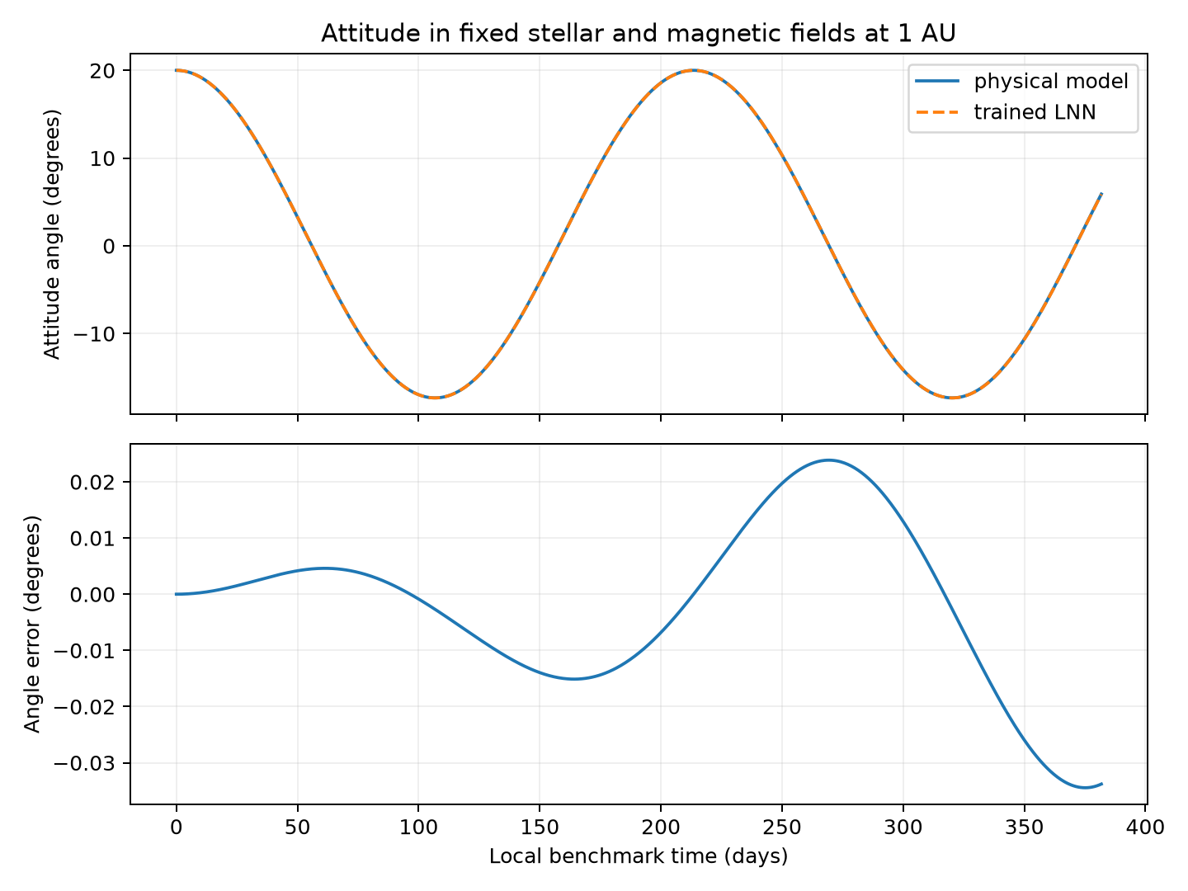
Reproduced evaluation of the saved attitude network. The upper panel compares the known and learned angles; the lower panel shows their difference. The time axis belongs to this fixed-field benchmark.
RMSE means root mean squared error: square each reported angle error, average those squares and take the square root. It is an average error measure, not the largest deviation. The small value supports useful local attitude prediction, but one initial tilt does not establish performance for all trajectories.
The model includes both magnetic and gravity-gradient effects. This run does not separately measure how accurately each contribution was recovered. A low total-force error is not proof that the network has uniquely separated the two physical terms.

How well the centrifuge model worked
The centrifuge starts at its design spin, with the habitat cable 1 cm longer than equilibrium and the counterweight cable 0.8 cm shorter. Both radial rates start at zero. The two models are integrated at 1,600 reporting times over 20 seconds. The cables and spin exchange energy without damping.
Trajectory metric | Measured RMSE
Habitat extension | 0.609778 mm
Spin rate | 0.0000498284 rpm
Habitat circular-motion gravity | 0.0000133772 g

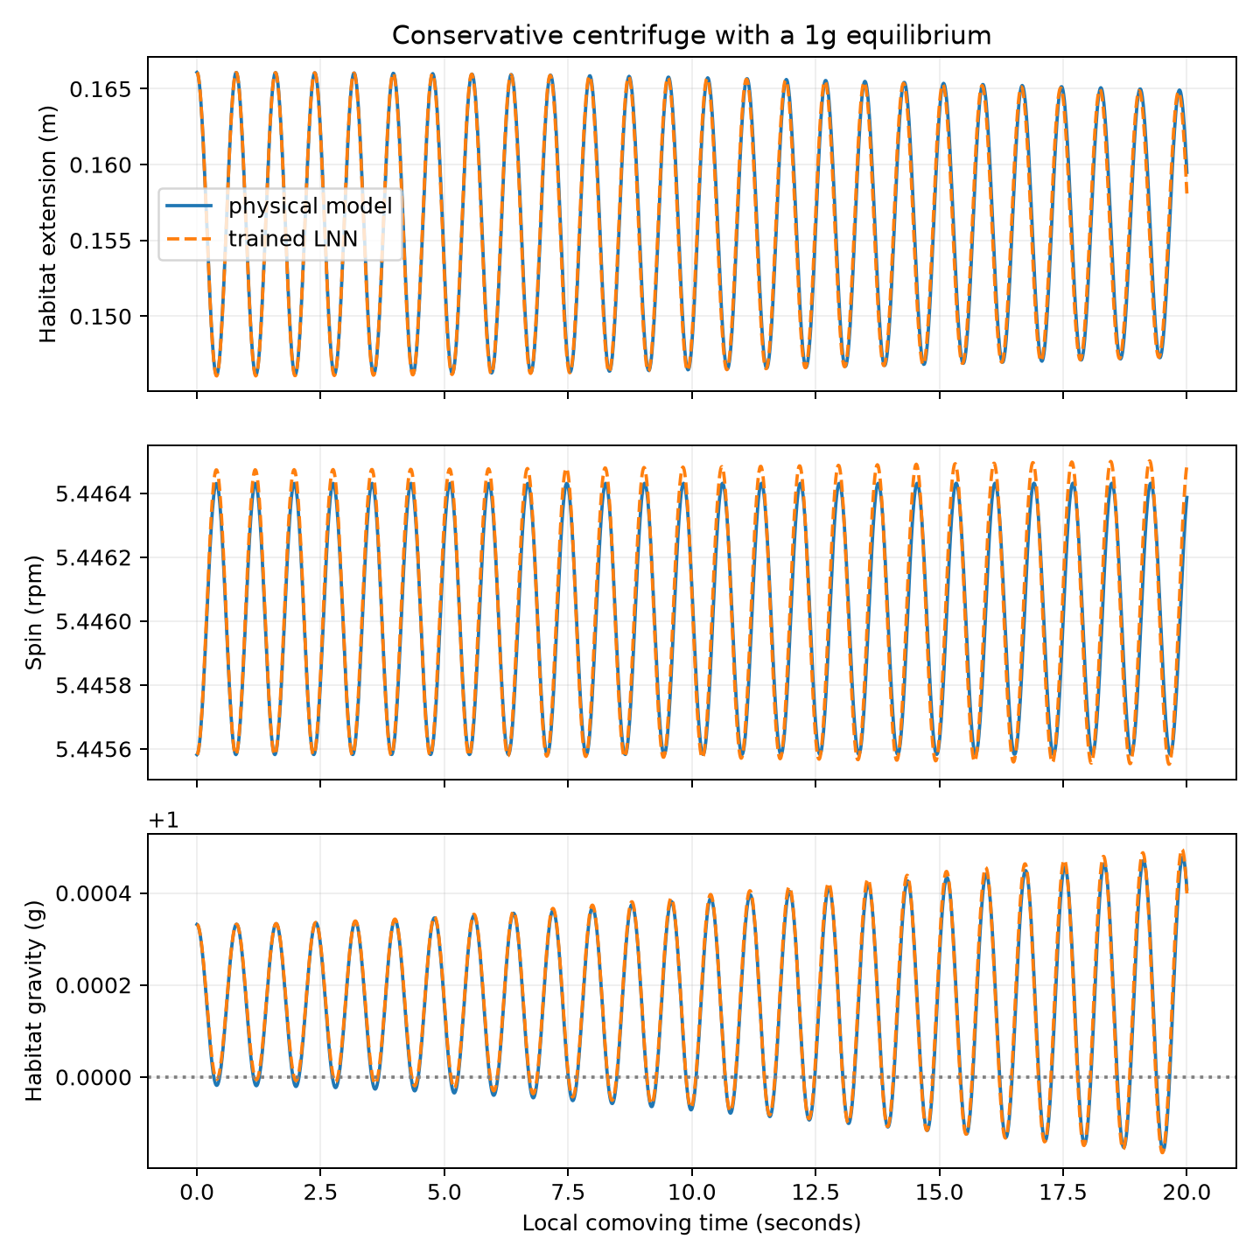
Reproduced evaluation of the saved centrifuge network. The panels compare habitat extension, spin and circular-motion gravity. The dotted line marks the one g equilibrium. The gravity axis has a +1 offset: a tick of 0.0004 means 1.0004 g.
The network follows the small elastic disturbance closely over this horizon. The gravity RMSE measures disagreement with the reference gravity curve; it does not mean the gravity curve itself stays within that distance of exactly one g. The oscillations remain because the model has no damping.

What the conservation results really show
The code computes energy from the Legendre formula E = q̇ · ∂L/∂q̇ − L. For these quadratic kinetic energies this becomes T + U. It evaluates the known energy on the reference path, the known energy on the learned path, and the learned energy on the learned path. Those are different checks.
$$E = q̇ · \frac{∂L}{∂q̇} − L$$
To see why energy is conserved, differentiate this expression with time. Terms involving acceleration cancel with the derivative of L. The remaining term is q̇ times the difference in the Euler–Lagrange equation, which is zero. A stationary Lagrangian therefore conserves its own energy in exact continuous motion.
$$\frac{\text{dE}}{\text{dt}} = q̇ · [\frac{d}{\text{dt}}(\frac{∂L}{∂q̇}) − \frac{∂L}{∂q}] = 0$$
Energy diagnostic | Attitude | Centrifuge
Known energy drift on the learned path | 1.12521 × 10⁻³ | 1.92570 × 10⁻⁷
Learned energy drift on the learned path | 1.58726 × 10⁻⁸ | 1.50277 × 10⁻¹¹
Known energy drift on the reference path | 1.58806 × 10⁻⁸ | 1.50474 × 10⁻¹¹

All three rows are maximum absolute changes divided by the same scale: the magnitude of the initial reference energy, with a 10⁻¹² floor. The potential’s reference level is fixed by the code. Changing an arbitrary energy offset can change a relative-energy percentage, so these numbers are meaningful within the stated convention.
The learned-energy drift is almost the same size as the reference solver’s drift. That supports numerical conservation of each model’s own energy. The larger known-energy drift on the learned path measures how much the learned dynamics depart from the chosen physical energy rule. For attitude it is about 0.1125%; for the centrifuge it is about 0.00001926%.
The centrifuge also has spin angular momentum drift of 3.89688 × 10⁻¹⁴ relative to its initial value. This follows from leaving spin angle out of the potential. It is an imposed symmetry, not a newly discovered law. Accurate motion and small known-energy error provide the additional evidence that the learned forces are useful.
The old solver uses JAX odeint with relative and absolute tolerances of 10⁻¹⁰. It checks that returned predictions are finite. These runs did not include a broad collection of failed cases or stopping rules of the newer training protocol; one finite trace should not be treated as a robustness study.

What has been learned and what remains untested
The attitude network learned a periodic potential whose derivative produces useful total turning forces. The centrifuge network learned an extension-dependent potential whose derivatives approximate the spring restoring forces. Acceleration examples constrain these slopes, while an arbitrary constant in the learned potential remains undetermined because it does not affect motion.

What was supplied in advance
We supplied the masses, inertias, cable geometry, quadratic kinetic energy, the periodic angle representation and the absence of spin-angle dependence. The acceleration calculation and conservation structure were also supplied. The networks did not infer these ingredients from observations. Calling the result a successful structured force model is more precise than saying it independently discovered every law of physics.

The reference checks
On a separate 32-state check, the hand-written attitude equations and automatic Lagrangian equations differed by at most 2.22 × 10⁻¹⁶ in scaled state derivatives. The centrifuge maximum difference was 2.78 × 10⁻¹⁶. The one g equilibrium identity also passed. These checks support the consistency of the implemented reduced equations; they do not certify every physical assumption.

Limits that matter to interpretation
The attitude calculation is planar and uses the hub inertia alone. The stellar distances are frozen and the rotor does not exchange angular momentum with the hub. The centrifuge fixes its rotation center and uses massless linear elastic cables, point end masses and a local clock. Neither experiment includes damping, impacts, fuel use or a validated cable strength model.
The function combined_lagrangian_si assembles translation, fields, attitude and centrifuge terms into a reduced expression. The reported results come from the separate scaled blocks, not from training or integrating that assembled function as a complete mission. Its existence is therefore not evidence of a validated coupled spacecraft.
The newer nine-coordinate generic LNN retains finite-hub motion and coupling in one action. It has a different architecture, budget and audit. Physical long training for that model remains gated until its time and field conventions are resolved. The successful rotating benchmarks do not clear that gate.

Where this approach is effective
These results support using a learned potential when the kinetic mechanics and symmetries are trustworthy and only the force landscape needs to be learned. Wider initial conditions, multiple training seeds, longer trajectories, comparisons with a direct acceleration model and checks of recovered force curves would be needed for a stronger claim about reliability or generalization.

Reading and reproducing the implementation
The derivations in this report describe the equations implemented in the local files below. The reported numbers come from the archived rotating experiment and an exact repeat evaluation of its saved checkpoints on October 12, 2026.
File or record | What it contains
phm_rotating_lnn.py | Assumptions, rotating energy formulas, analytical labels, networks, training, evaluation and plots
phm_lnn.py | Shared automatic motion solver, integration helper and Legendre energy calculation
results_extended/assumptions.json | Numerical design parameters, scales and approximation list
results_extended/metrics.json | Original results quoted in the report
results_extended/attitude.pkl and centrifuge.pkl | Saved parameters and training histories
conservative_training/rotating_report_work/ reproduced_results | Repeat evaluation and newly generated trajectory plots

From input to prediction
main chooses whether to check, train or evaluate. make_data creates states and calls analytical_dynamics for their labels. train builds the network, repeatedly compares predicted and reference accelerations, updates its parameters and saves the best training checkpoint. evaluate integrates the known and learned Lagrangians from the same initial state, computes errors and conservation measures, and writes plots and metrics.
The constants near the top of phm_rotating_lnn.py define the hardware assumptions. gravity_gradient_energy and magnetic_energy supply the attitude reference. kinetic, potential and exact_lagrangian define the scaled reference. assumptions writes the parameter record; check compares explicit and automatic dynamics. These names identify where each derivation appears in the code.

Optional commands for a reader who wants to rerun it
Run the first command from the project folder to check the equations. To repeat evaluation without retraining, place copies of the two saved checkpoint files in a new output folder and use the second command. A fresh training experiment should use its own output folder so it preserves these records.
.venv/bin/python phm_rotating_lnn.py --check
.venv/bin/python phm_rotating_lnn.py --evaluate \
--output-dir YOUR_NEW_OUTPUT_FOLDER
A fresh training run uses --train --steps 10000 --samples 256 with a new output folder. Reproducing this structured experiment does not reproduce the newer 300,000-update generic LNN protocol; they answer different research questions.

